**ALM Process for admin page**

**1-open VMware**

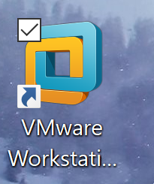

**2-Click on window 7x64**

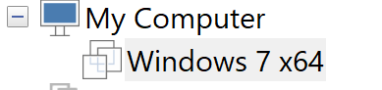

**3- You should see “power on this virtual machine option”**

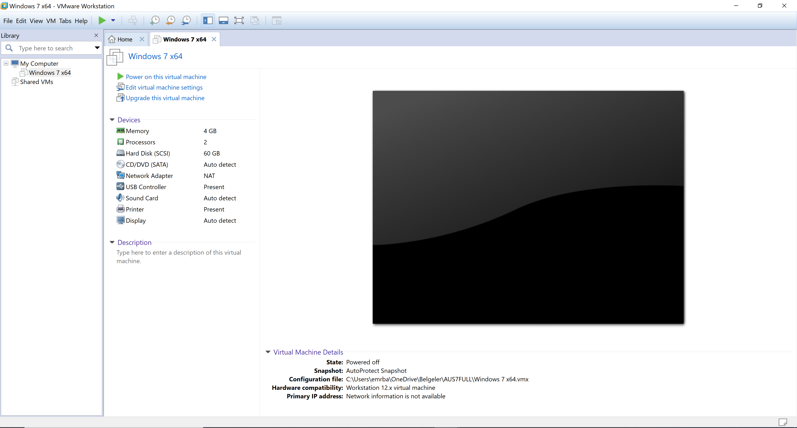

**4- Click on power on this virtual machine**



**5- You should see home screen**

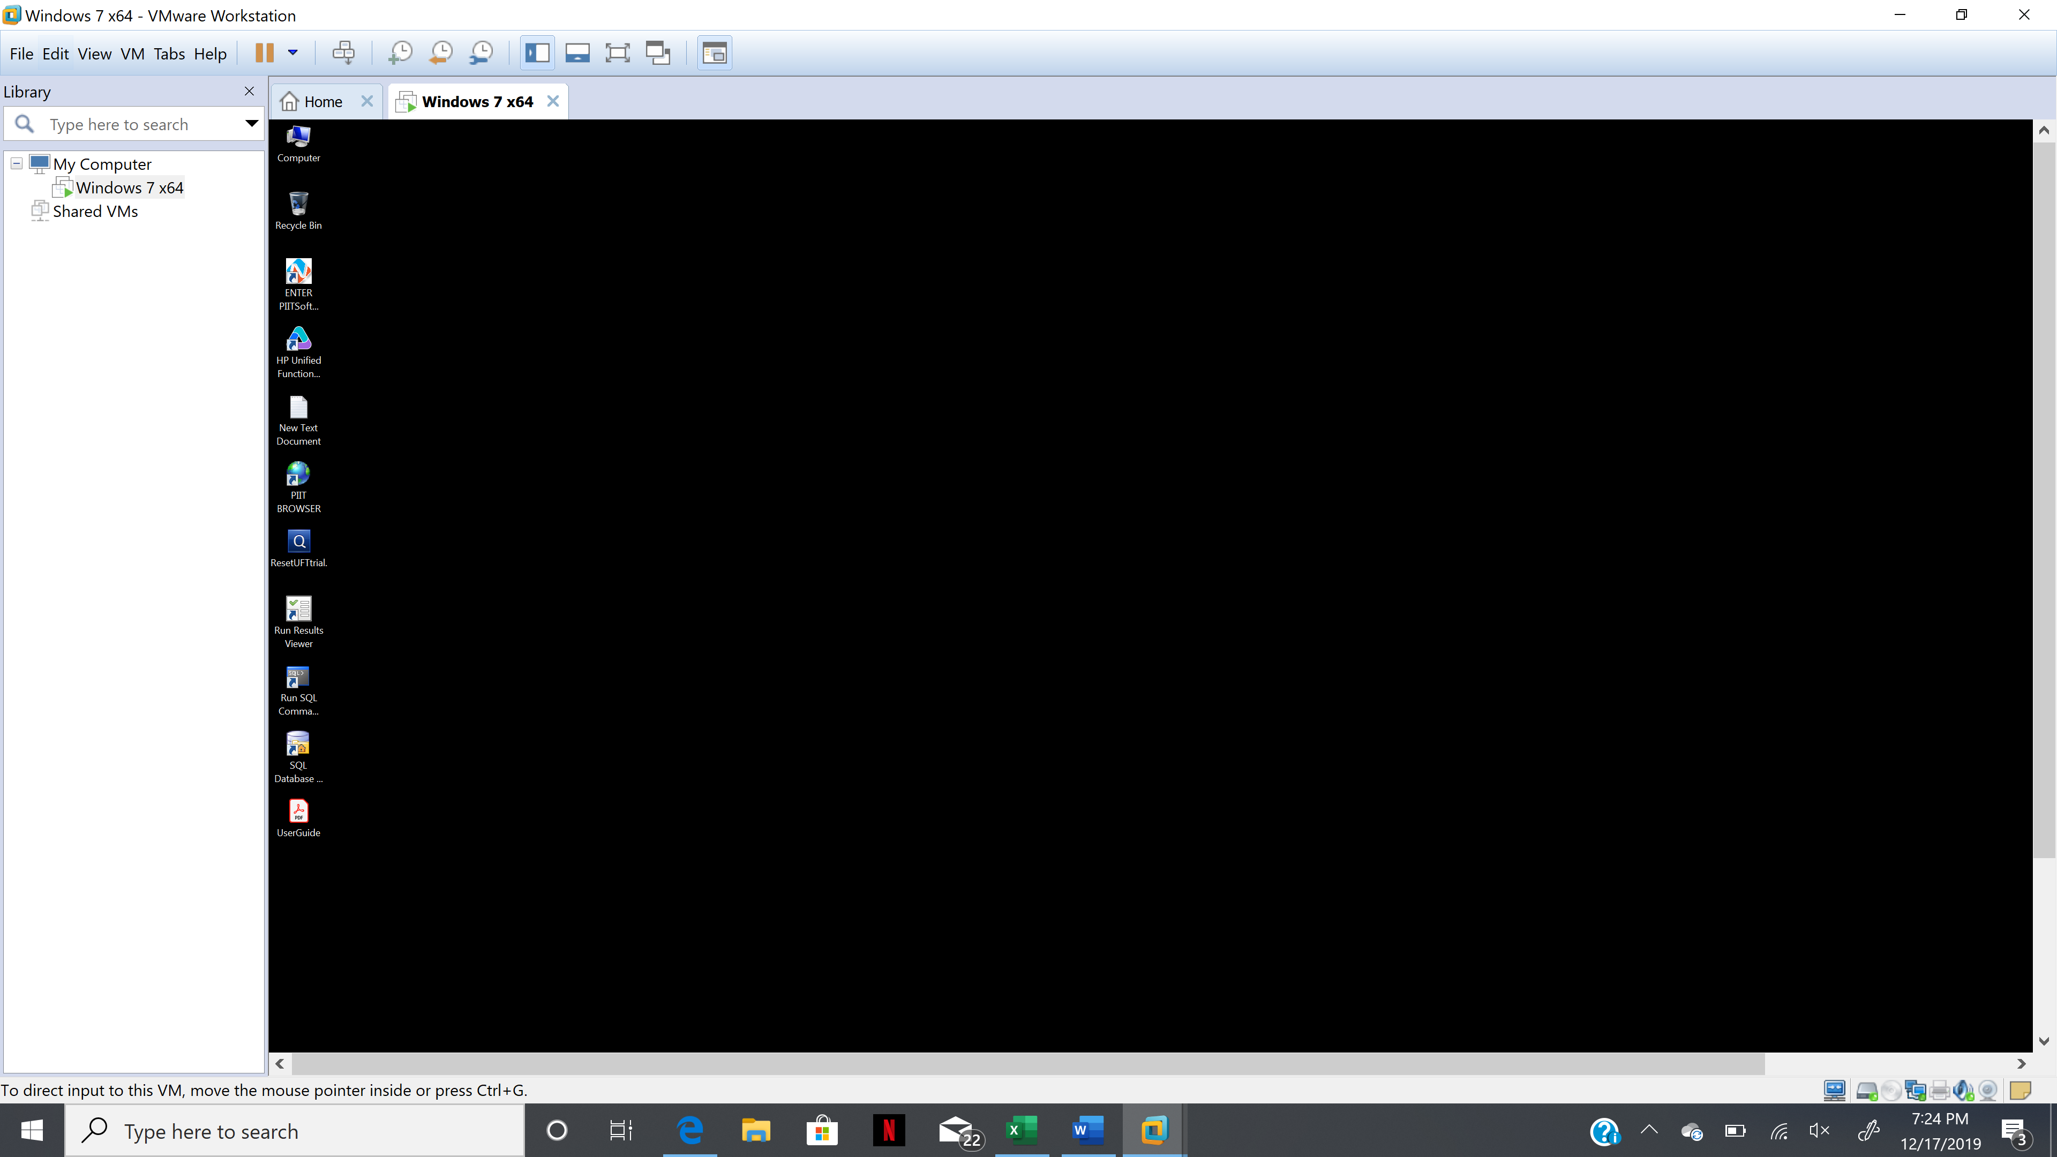

**6- Click on ALM logo**

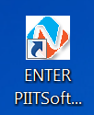

**7- If you do not see ALM logo then please restart your VM again and then wait for 5-10 mins before you try to open ALM**

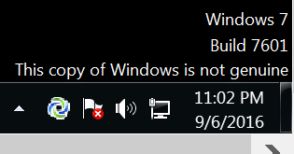

**9- First one- Click on Site Administration to configure your project**

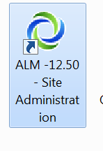

**10- you should see this page**

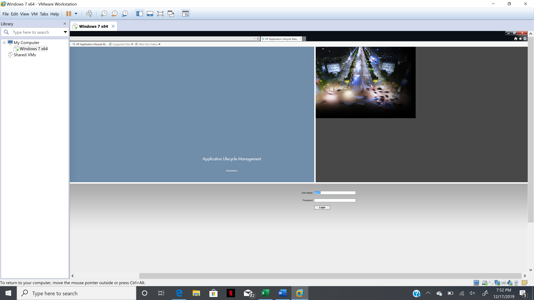

**11- Login Details:**

**Username: alm12**

**Password: alm12**

**Click login button**

**12- You should be able to see Admin page**

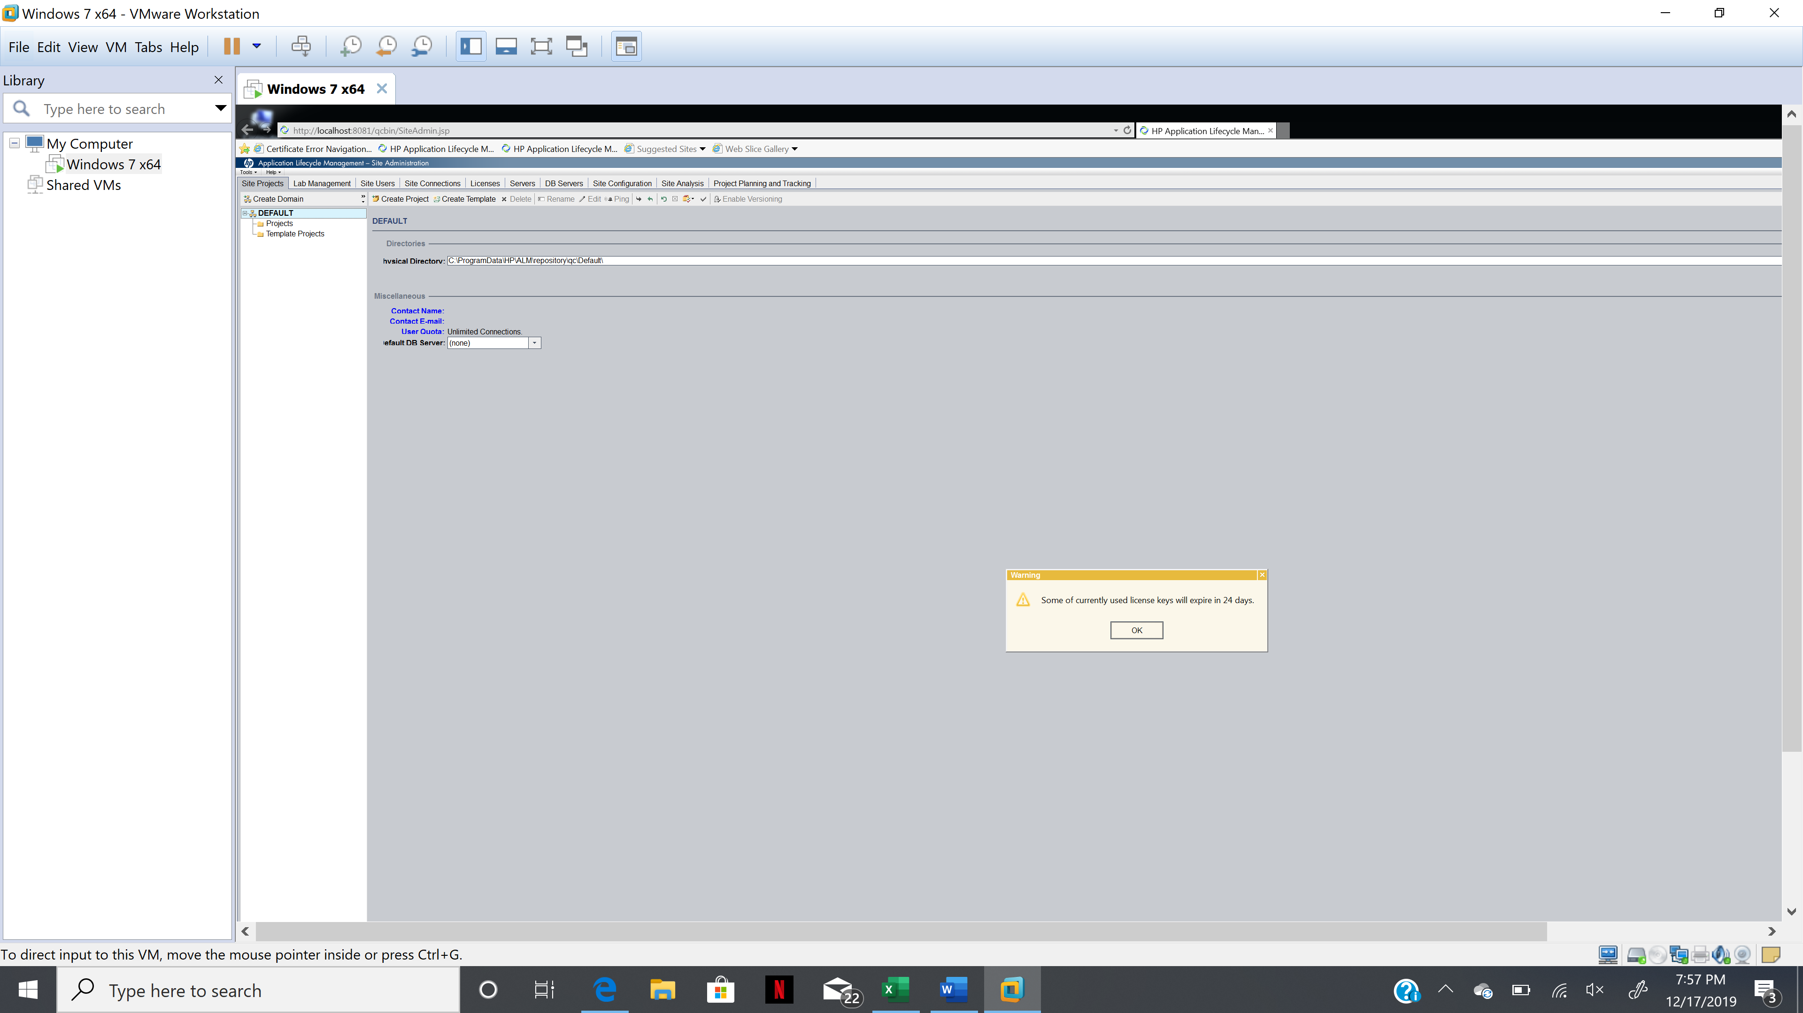

**13- click on create domain**

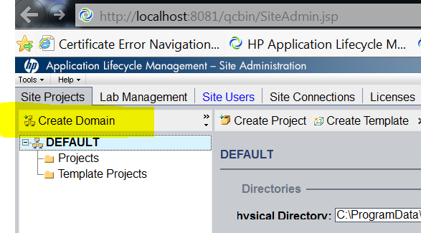

**14- Domain name box should come up**

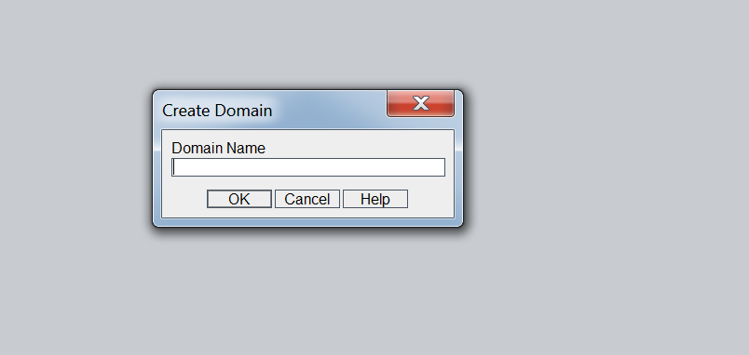

**15- Type HR as domain name and click ok**

**16-click on the domain where you want to start new project**

**17- click on create project**

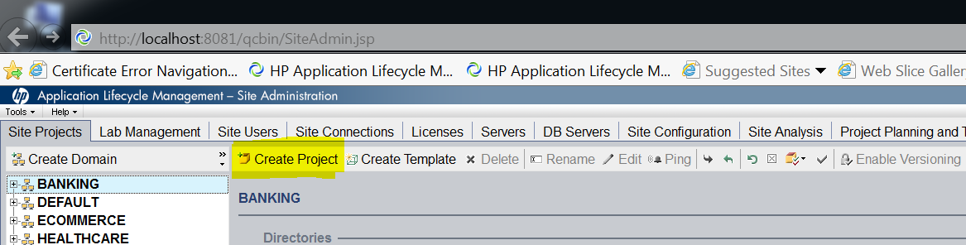

**18- Project options should appear**

**Create an empty and click next**

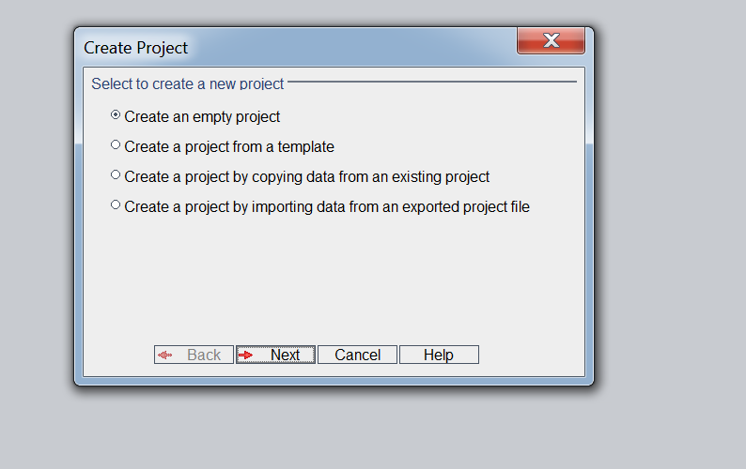

**19- Type in the project name and click next**

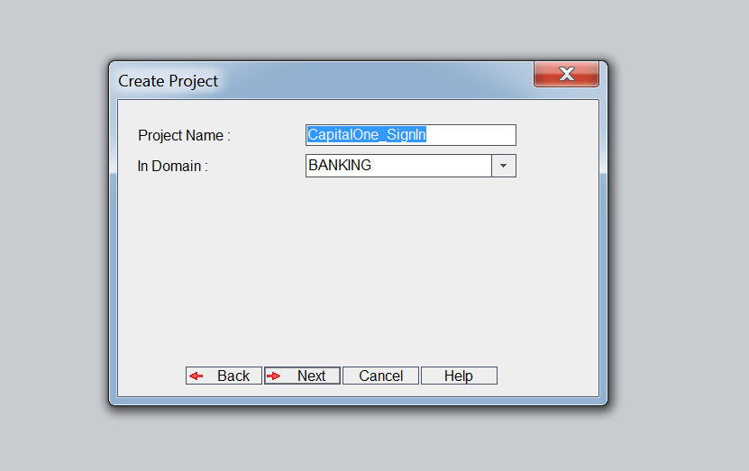

**20- Click next without changing anything**

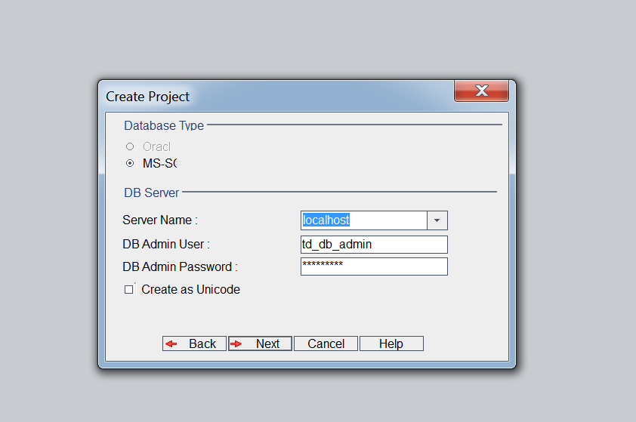

**21- select the user and click on green arrow to add a user**

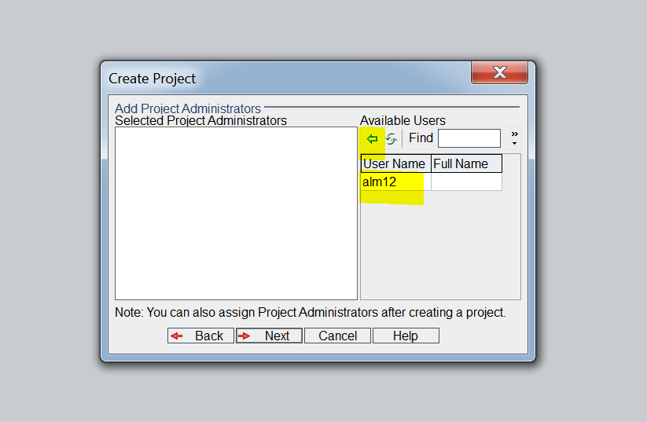

**22- this is how it should look when you add a user then click next**

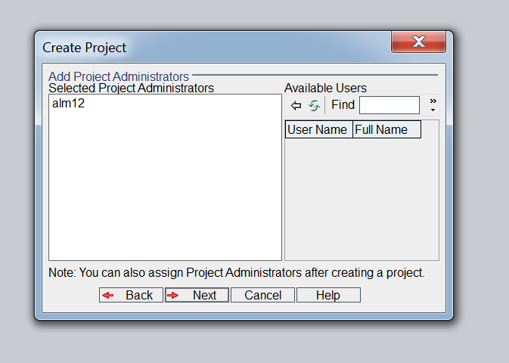

**23- Select the extension you want to add to your project then click next**

**For now just don’t add anything , just click next**

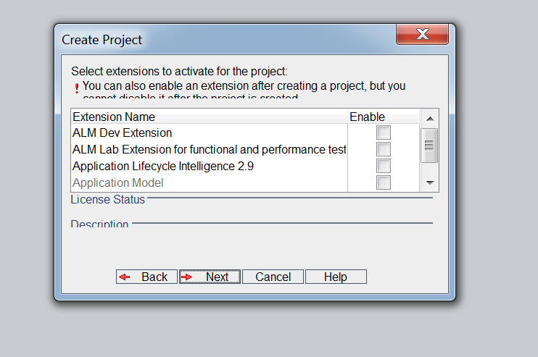

**24- click on create**

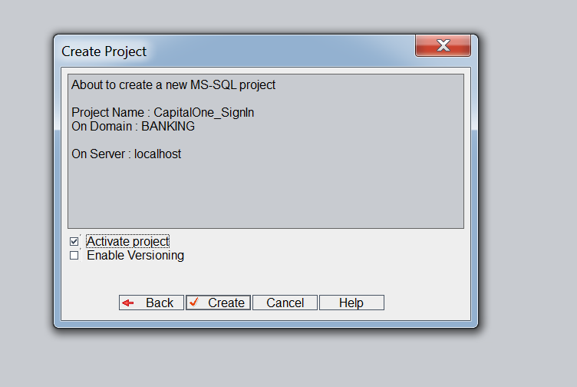

**25- project created**

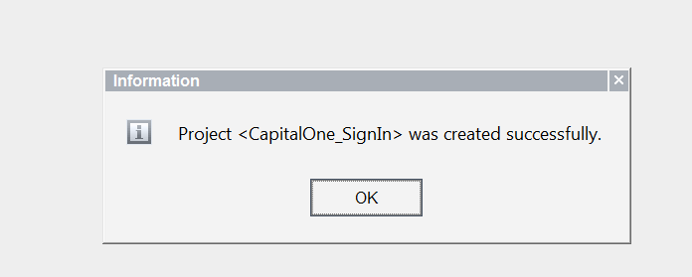

**26- Click on site users to add or remove users**

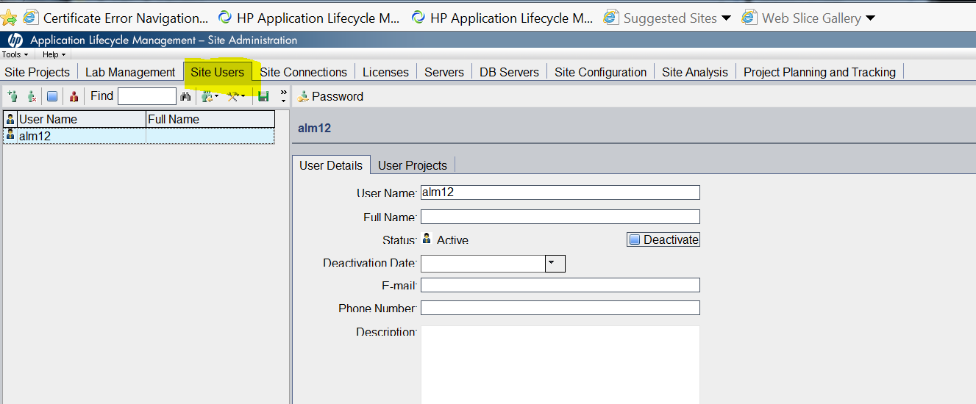

**27- click on new user logo that’s highlighted**

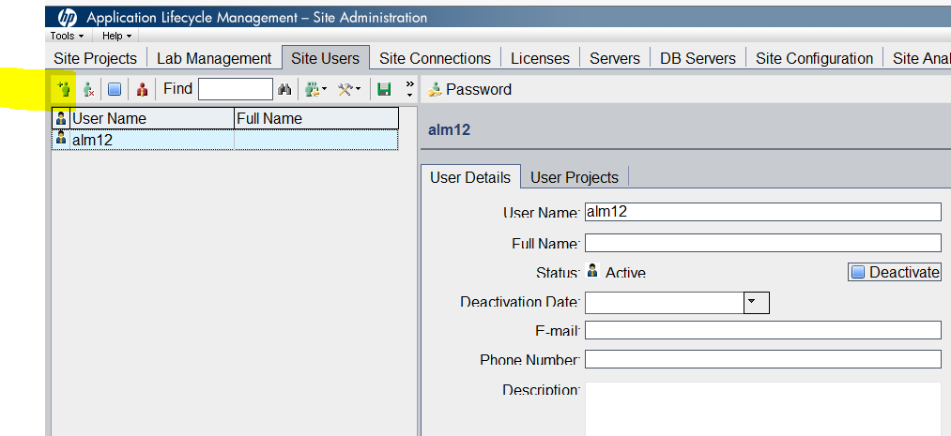

**28- type user info then click ok**

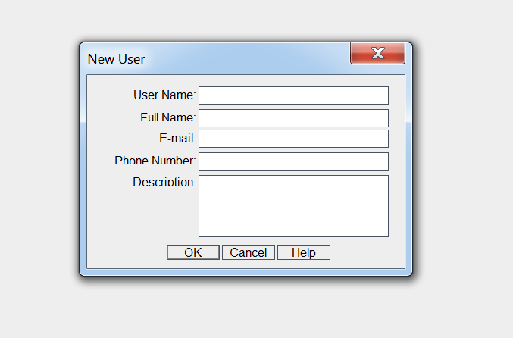

**29- User added**

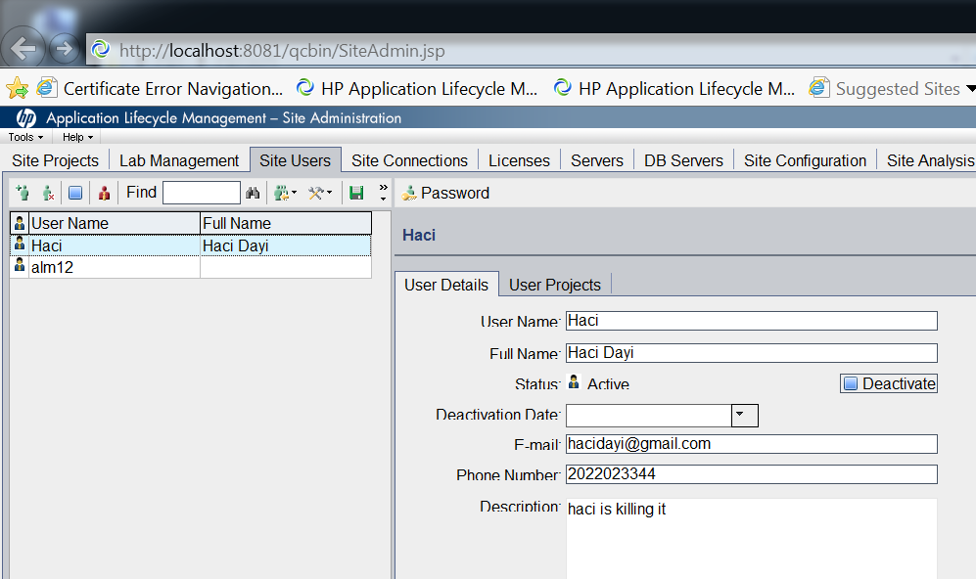

**30- to add a password for a user. From user details click on password button**

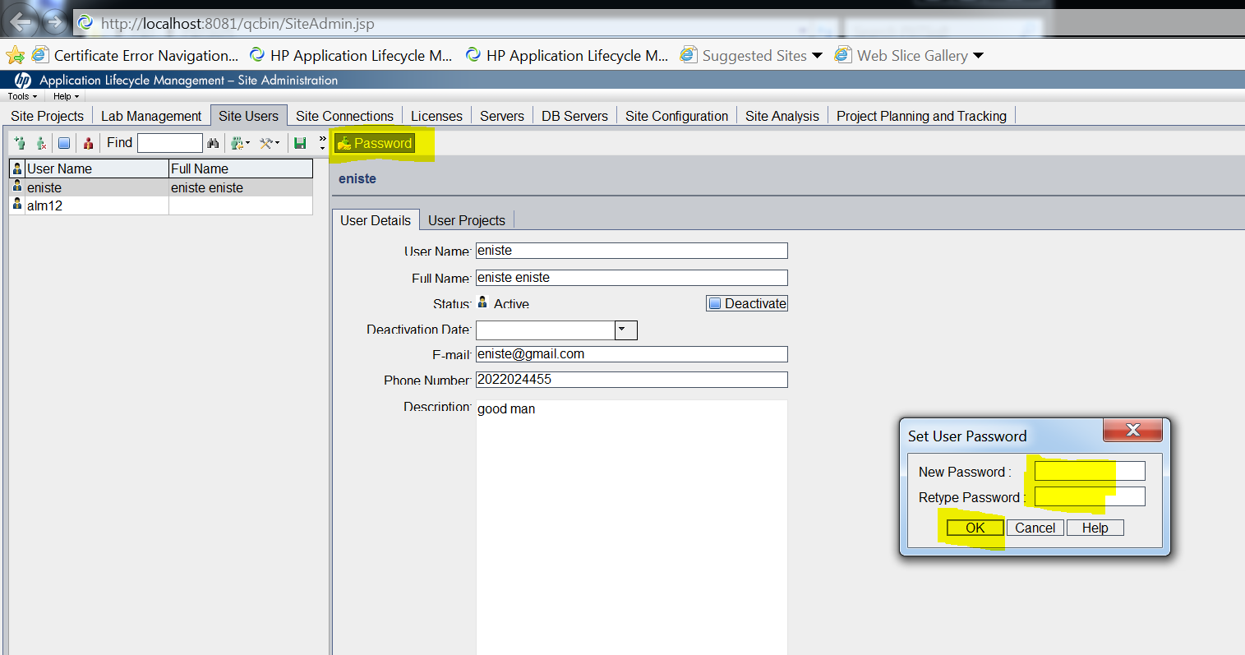

**31- In order to assign project to a user**

**-click on user project then**

**- Select projects**

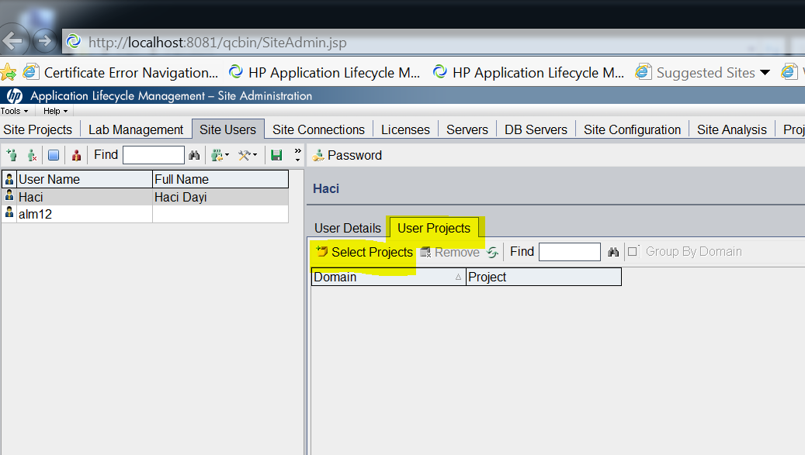

**32- Then you select the project you want to assign to that specific user, check the box next to project name then click on green arrow to assign**

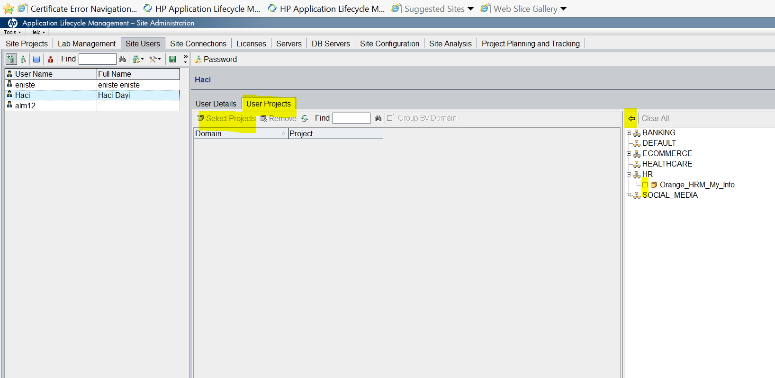

**33- click on site configuration then scroll all the way down to wait before disconnect**

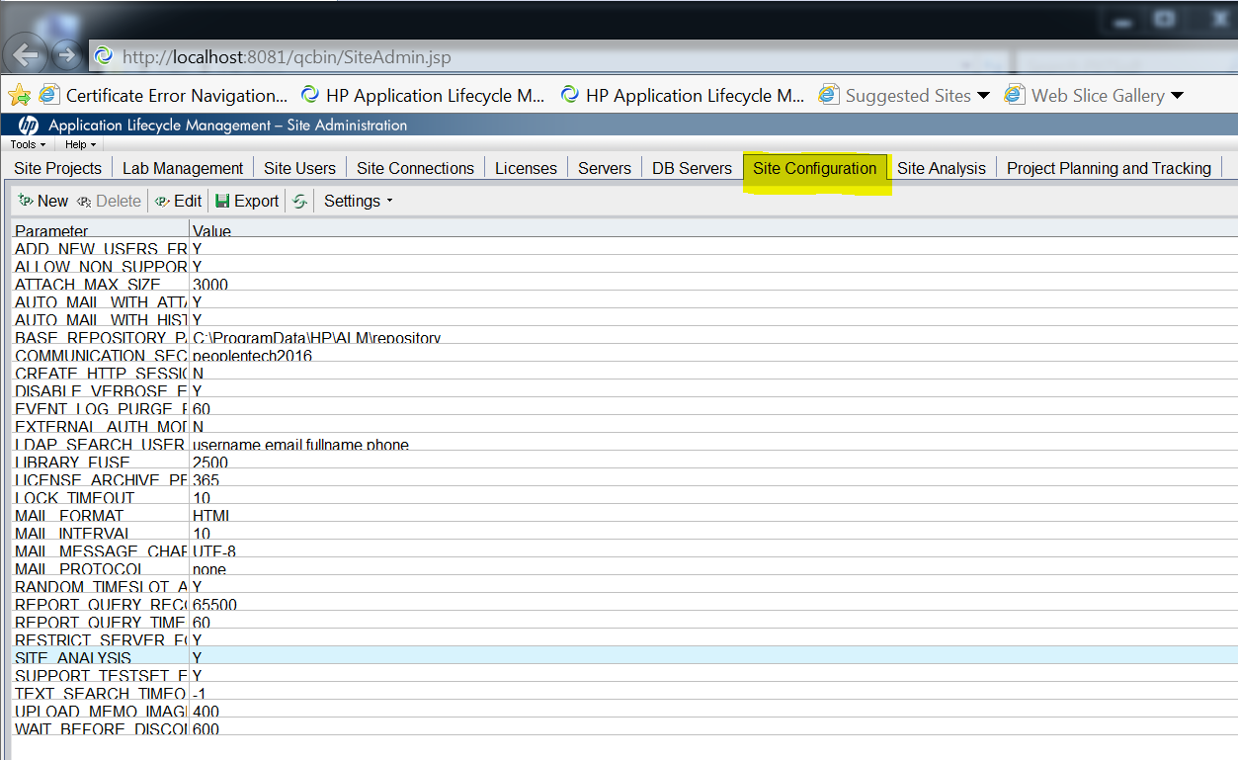

**34- make sure wait before disconnecting is more than 600**

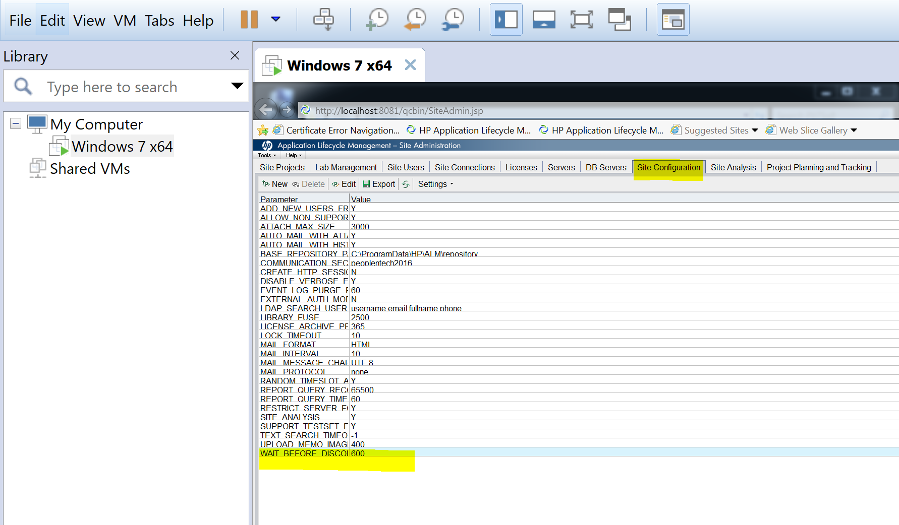

**35- select wait before disconnect then click on edit and make it 6000**

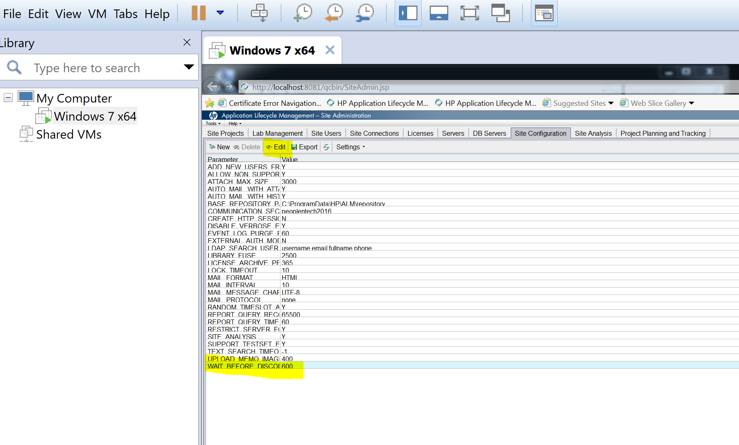

**36- After creating a domain you can add contact number and email for that specific domain**

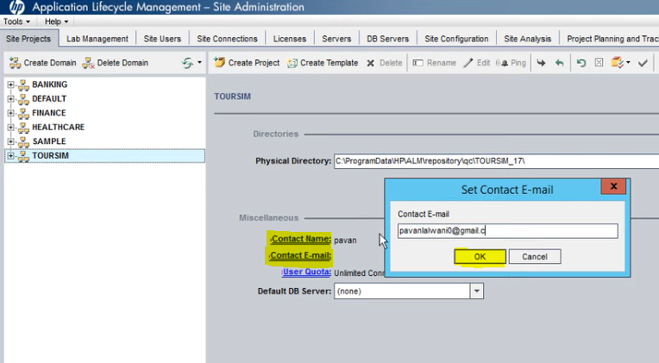

**When you do changes in domain and not reflected on the left click on green refresh button**

**Also if you want to delete a domain first delete the projects under the domain, then delete the domain.**

